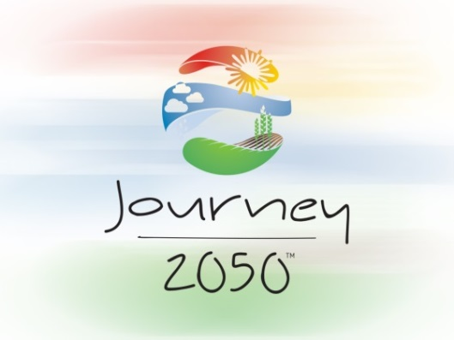

Teacher’s Guide:
Distance Learning

Using Journey 2050 From Home:
All the program materials are available online for free.

Teachers and Parents can access the complete curriculum from the “Teacher Experience” tab.
- Why you should register: in order to access the full curriculum (lesson plans, PowerPoints, handouts with answer keys) in the Step-by-Step Guide you will need to have an account log-in.
  - When you create an account, you are assigned a Teacher Code, allowing you the option to access student reports from the Journey 2050 game.
- Student DO NOT need to create a Journey 2050 account. Students can access the lesson PowerPoints, handouts, videos and game levels from the “Student Experience” page.

To ensure success, use a supported web browser or device to play the Journey 2050 game, as listed here: http://journey2050.rnp.io/teachers/online/activities_and_resources

The Online Experience: accessible once you log-in to your account, this tab contains the program curriculum. You will find every level and its accompanying resources listed.
  - Each level has a complete lesson plan, PowerPoint, video and additional resources Levels 1-6 have a game level that students will need to access using the Journey 2050 app or online platform. Level 7 is the Program Summary lesson centered around Project-Based Learning.

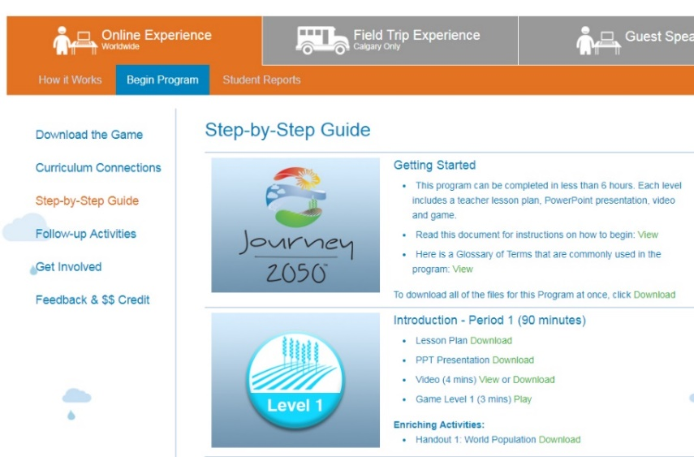

Tips and Tricks:

Additional tips for using the program during school closures can be found on the “J2050 From Home” page

Teacher Reports: an optional tool for educators, providing an individual student report of progress if they use the Journey 2050 gaming platform. Three reports are produced (completion of level 1-4, 5 and 6). Your teacher code must be inputted by the student at the start of the game for the report function to work. Please see the document “Teacher Report Tip Sheet” for further guidance.

Educational Videos: Level 1-7 has an accompanying video created to enhance the lesson. Each video also plays at the start of the coordinating level of the Journey 2050 Game (except for level 6).
  - The program was designed with the assumption the video would be presented by the educator in class as the lesson plan is completed.
  - If students are playing the game at home and have inputted a teacher code (so that a report is later produced) it will bypass the educational video for each level.
    - Suggestion: Have the students watch the video designated for each level on their own so that the teacher report will function.
    - Please Note: If teacher code is not inputted at the start of the game the videos will play but the student’s report will NOT be produced.

Direct YouTube Links to Videos: also provided in the Step-by-Step Guide
- Lesson 1: https://www.youtube.com/watch?v=zYecU_gJdxA&feature=youtu.be
- Lesson 2: https://www.youtube.com/watch?v=chdtdWEV-0s&feature=youtu.be
- Lesson 3: https://www.youtube.com/watch?v=bI7hYAomzGk&feature=youtu.be
- Lesson 4: https://www.youtube.com/watch?v=d1ogX94qJIg&feature=youtu.be
- Lesson 5a: https://www.youtube.com/watch?v=RMu7NtScdhU&feature=youtu.be
- Lesson 5b: https://www.youtube.com/watch?v=ZvdtHNe8zGw&feature=youtu.be
- Lesson 6: https://www.youtube.com/playlist?list=PL7B61381EE0438243
- Lesson 7: https://www.youtube.com/watch?v=qexChWNFY5E&list=PLwsfnkzf7bW49kNQhZeKOdmpuH7vTGShB&index=20

Farmers 2050: Free Educational Farming Game
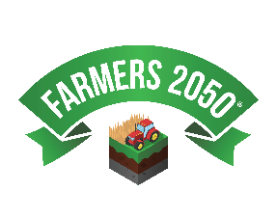
- Many educators use Farmers 2050 as an additional resource to continue student engagement and learning in a virtual farming experience from their own devices as a take home assignment.
  - The game continues to challenge players to balance their sustainability and make a positive impact on the global food supply.
- The game is free to download and play, available in the App Store or Google Play.
- Global Events occur on a nearly weekly basis in the game. These team challenges, designed to highlight the UN 17 Sustainable Development Goals, can be accessed when players reach level 5 in the game. Players can then either join or start a team.
  - Suggestion: Have students compete in Global Events in teams assigned by the educator for a friendly competition.
- Learn more about Farmers 2050 here: http://www.farmers2050.com/

Additional Agricultural Resources:
Explore more here: https://www.journey2050.com/agricultural-resources/

Or check a few of our program partners:
- National Agriculture in the Classroom (USA) https://www.agclassroom.org/
- Agriculture in the Classroom Canada https://aitc-canada.ca/en-ca/
- Nutrients for Life (USA) https://nutrientsforlife.org/ Nutrients for Life (Canada) https://www.nutrientsforlife.ca/
- National FFA Organization https://www.ffa.org/
- 4-H (USA) https://4-h.org/home/ 4-H (Canada) https://4-h-canada.ca/
- Seed Survivor https://seedsurvivor.com/
- Caring for our Watersheds https://caringforourwatersheds.com/
- WE Schools https://www.we.org/en-US/our-work/we-schools/

Questions? Email programs@naitco.org

